**Department of Systemics**

**School of Computer Science**

University of Petroleum and Energy Studies

cid:image003.png@01D81F60.F8BDA810

**ADVANCE DATABASE MANAGEMENT SYSTEM**

**LAB FILE**

Submitted by

**Akshat Negi**

**R2142220414**

**Batch - 2**

B.Tech Computer Science and Engineering(CSF)

Submitted to

**Dr. KOTHA VENUGOPALCHARY**

Assistant Professor (SS)

SOCS, UPES

**LAB EXPERIMENT – 3**

**Created a Database for Lab 3 Experiment.**

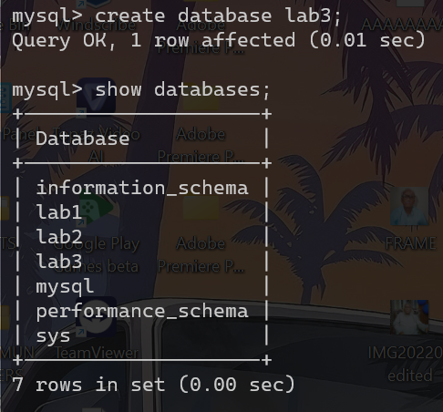

**Select Database for inserting Tables.**



**Supplier Table Format Creation**

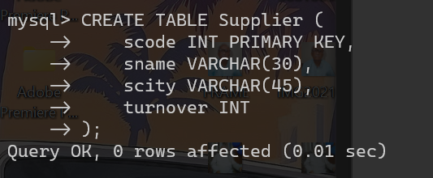

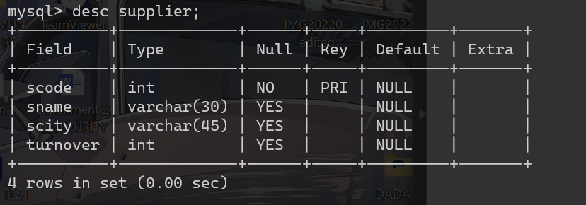

**Part Table Format Creation**

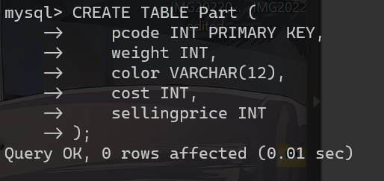

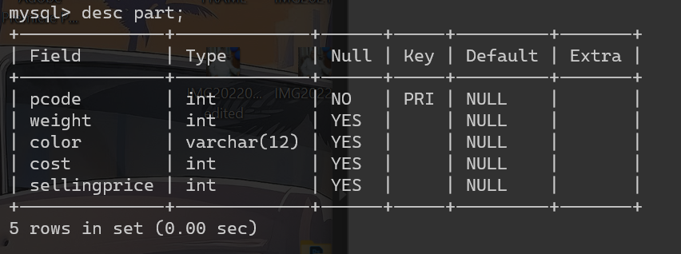

**Supplier Table Format Creation**

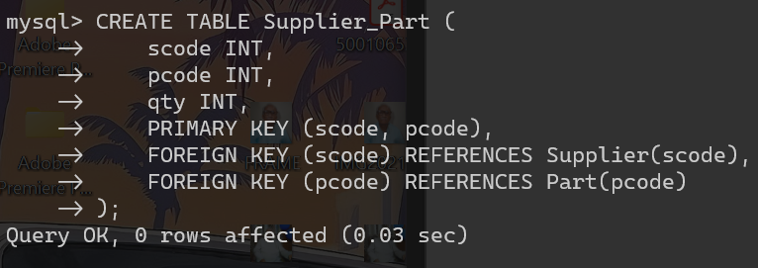

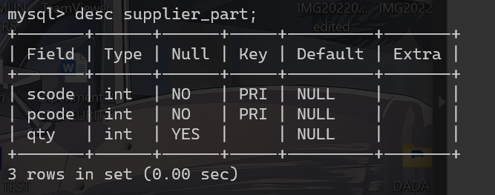

**All Tables Inserted.**

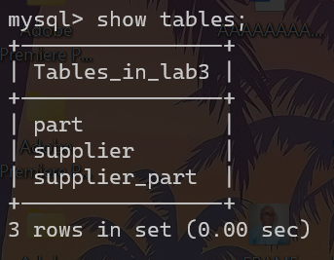

**DATA Insertion in PART Table**

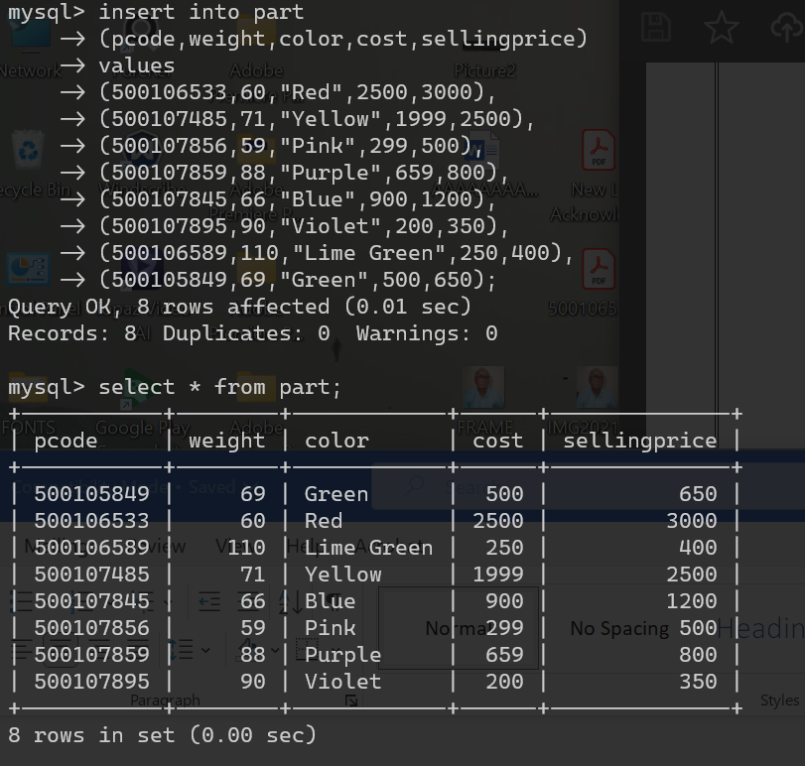

**DATA Insertion in SUPPLIER Table**

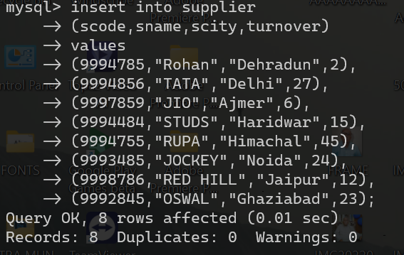

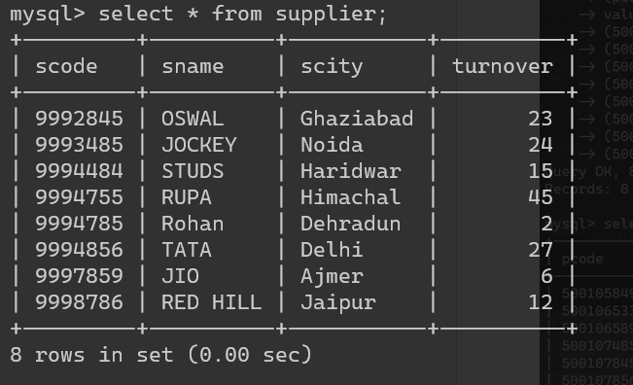

**DATA Insertion in SUPPLIER_PART Table**

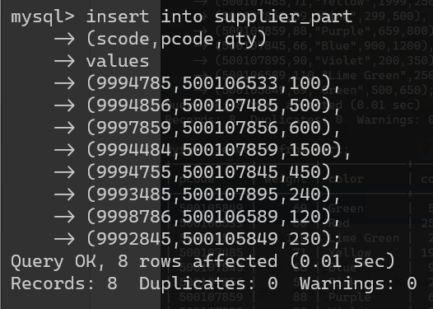

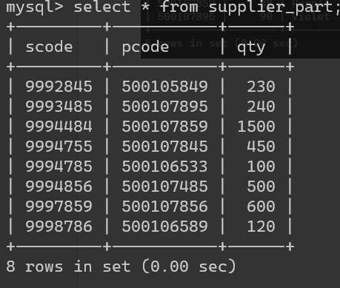

***3. Write appropriate SQL Statement for the following:***

**1)** **Get the supplier number and part number in ascending order of supplier number.**

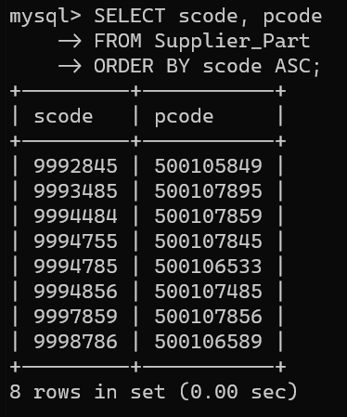

**2)** **Get the details of supplier who operate from Bombay with turnover 50.**

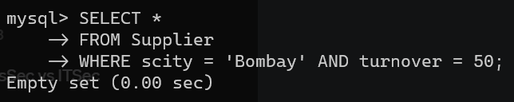

**3)** **Get the total number of supplier.**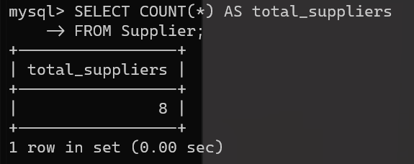

**4)** **Get the part number weighing between 25 and 35.**

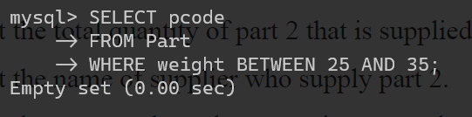

**5)** **Get the supplier number whose turnover is null.**

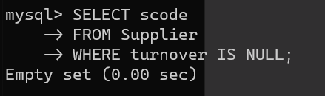

**6)** **Get the part number that cost 20, 30 or 40 rupees.**

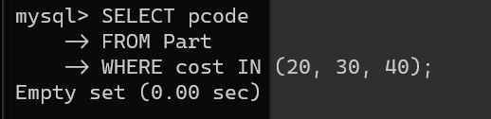

**7)** **Get the total quantity of part 2 that is supplied.**

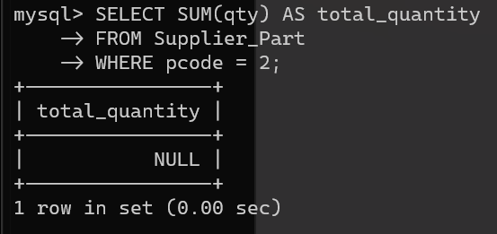

**8)** **Get the name of supplier who supply part 2.**

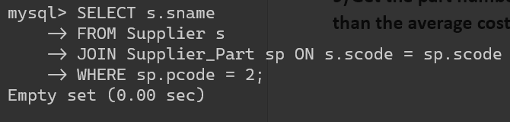

**9)** **Get the part number whose cost is greater than the average cost.**

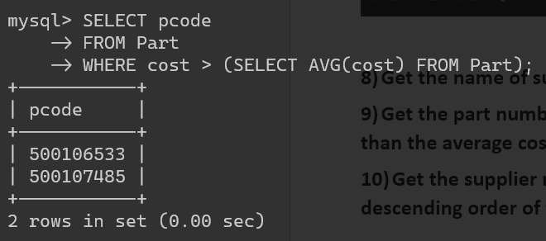

**10)** **Get the supplier number and turnover in descending order of turnover.**

